**PROPOSAL**

**Zookeeper System Enhancements**

**Version 1.1.2**

**Prepared by**

**Group 8**

Harmanpreet Kaur

Duy Phuc Tran

Viet Duc Hoang

1. Table of Contents

1. Stakeholders 4

1.1. Team members 4

1.2. Client 4

1.3. Supervisor 4

1.4 Unit Coordinator 4

2. Document revision 5

3. Term of References 5

3.1. Zoodata 5

3.2. Zookeeper 5

4. Rationale 6

5. Scope and objectives 7

5.1 Scope 7

5.2 Objectives 7

5.3 Out of Scope 7

6. Project Approach 7

6.1 Approach justification 7

6.2 Project model 7

6.3 Project plan 7

7. Skill and knowledge involved 8

8. Cost 9

9. Abbreviation 9

10. References 9

# Stakeholders

## Team members

|  |  |  |  |  |
| --- | --- | --- | --- | --- |
| **Student ID** | **Name** | **Phone**  **Number** | **Email** | **Master’s degree** |
| 10477967 | Harmanpreet Kaur (Developer) | 0470 202 305 | harman11@our.ecu.edu.au | Cyber Security |
| 10418791 | Phuc Duy Tran (Developer) | 0433 945 262 | dptran@our.ecu.edu.au | Computer Science |
| 10489643 | Viet Duc Hoang (Leader) | 0402 735 823 | hducviet@our.ecu.edu.au | Computer Science |

## Project client

|  |  |  |  |
| --- | --- | --- | --- |
| No. | Name | Role | Email |
| 1 | Robyn Hukin | Project sponsor | robyn.hukin@zoodata.com.au |
| 2 | Sarah Amy Joseph | Project supervisor | sjoseph@zoodata.com.au |
| 3 | Jinho Jang | Technical supervisor | jinho.jang@zoodata.com.au |
| 4 | Jayne Briggs | Admin user | jayne.briggs@zoodata.com.au |

1. Document revision

|  |  |  |  |
| --- | --- | --- | --- |
| **Version** | **Date** | **Changes description** | **Author** |
| 1.0.0 | 8/8/2020 | Prepare document structure | Viet |
| 1.0.1 | 8/8/2020 | Added stakeholder table  Added term of references | Viet |
| 1.0.2 | 8/8/2020 | Added document revision | Viet |
| 1.0.3 | 8/8/2020 | Added Zookeeper description | Viet |
| 1.1.0 | 9/8/2020 | Update document structure | Viet |
| 1.1.1 | 9/8/2020 | Added scope and objective, project approach, skill and knowledge involved, cost, abbreviation and references | Viet |
| 1.1.2 | 9/8/2020 | Update team member information | Viet |
| 1.2.0 | 11/8/2020 | Update subheadings | Nathan |
| 1.2.1 | 11/8/2020 | Added aims, objectives and background of study | Nathan |

1. Term of References

## Zoodata

**Zoodata** is an IT solution provide with twenty-one years of experience, founded in Perth, Western Australia and cooperates within different sectors and departments including health, government and corporates. With extensive experiences and rich expertise, Zoodata poses to be a major IT pioneer and trusted partner in Perth.

## Zookeeper

**Zookeeper** is web application and it was designed to replace the timesheet system which as still utilized by the client. The previous timesheet system called **Task Tracker**. Currently, the new timesheet system, Zookeeper is still in development stages and require to add more feature into its system.

1. Rationale

More than five years ago, Jinho Jang, a software engineer of Zoodata created the very first task tracker for Windows desktop application, universal application. The main problem is they cannot access task tracker remotely but within the office only. Zoodata’s objective is to develop a task tracker for web application bases on Jinho’s work. Later in 2019, a group of Curtin computer science student sent a proposal to Zoodata with an idea to bring the current task tracker into the cloud. During the design and development stages, Curtin students got an unfortunate incident with Zoodata which derailed their work. According to Robyn Hukin, the managing director of Zoodata, Curtin's students work was nearly successful. She also states that their source code was beautiful. As a result, Zoodata’s developers agree to continue to build and enhance the unfinished work.

Curtin computer science students build Zookeeper web application bases on Microsoft Technology which is ASP.Net Core as its backend. They used Entity Framework and MySQL to store data. The frontend framework is Blazor, also a Microsoft technology that was released on May 20, 2020.

|  |  |  |  |
| --- | --- | --- | --- |
| **Identify Objective** | **Current situation** | **Desire outcome** | **The gap** |
| * Work on the current source code. * Connect to database * ­­Complete several unfinished features * Write more unit tests * Tidy up validation * UI design * Reporting | * Unfinished. * Unable to use outside the premises * Unable to connect to local database. * Has lots of bugs. | * - Deliver the project with selected unfinished feature in the backlogs. | * Only 2.5 months to finish * Lack of knowledge with Blazor framework. * Lack of development document from Curtin’s students. * ECU interns don’t have access to zoodata account in order to bypass the AAD login. |
| **Action & Requirement** | | | |
| * Using agile development methodologies. * Using Azure DevOps for project management platform. * Using Visual Studio 2019/2020/Code. * C#, HTML, CSS, Javascript. * Using Blazor as frontend * Using ASP.NET Core as backend. * Using MySQL for database. | | | |

1. Aim of the project

The aim of the project is to create a website system that allow users to manage the tasks by creating, updating and deleting tasks and to replace the existing timesheet system called Time Tracker which as still utilized by the client.

1. Objectives of the project (Need to be improved)

The objectives of the project will be to:

- Develop a website application using C#, Blazor, EntityFramework, mySQL; and to

- Manage timesheet through; and to

1. Background of the study (Still need to be paraphrased and cited)

Before companies begin using timesheets, time periods are defined in the system. Most have a self-service module for employees to enter their time after supervisors set up parameters. These may include the work week, shift hours and overtime categories. Once these parameters are set, each employee receives login information.

Timesheets are a way to avoid illegal or lost information connected to these positions. Even when contractors work seasonally or at multiple locations, one centralized time tracking module can help to secure accurate payroll data.

Tracking time accurately, whether for regular employees, mobile workers or contractors, helps to reduce payroll costs. Employers have a more efficient system for each category of workers. They have a visual representation of what it takes to have a productive labour force.

1. Review of literature (Harry’s)

- Module 2 & 3 will explain more about this. Please have a look.

1. Project schedule (Viet’s)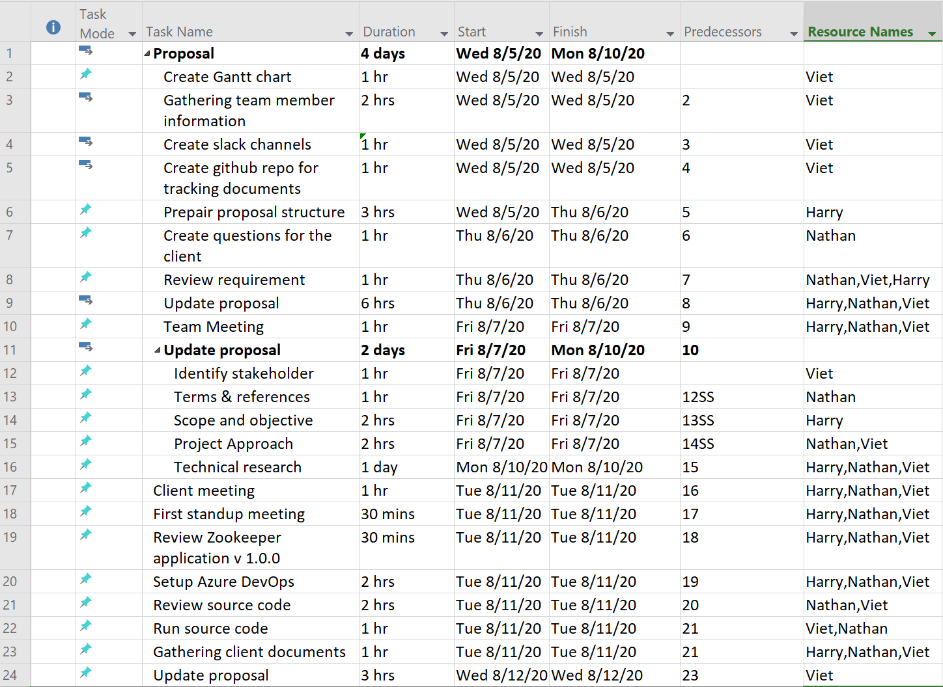

Figure 1Gantt Chart

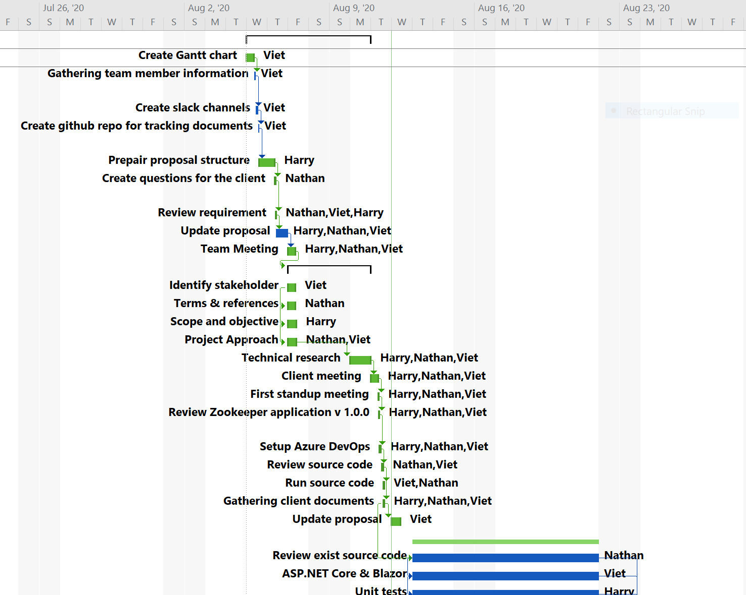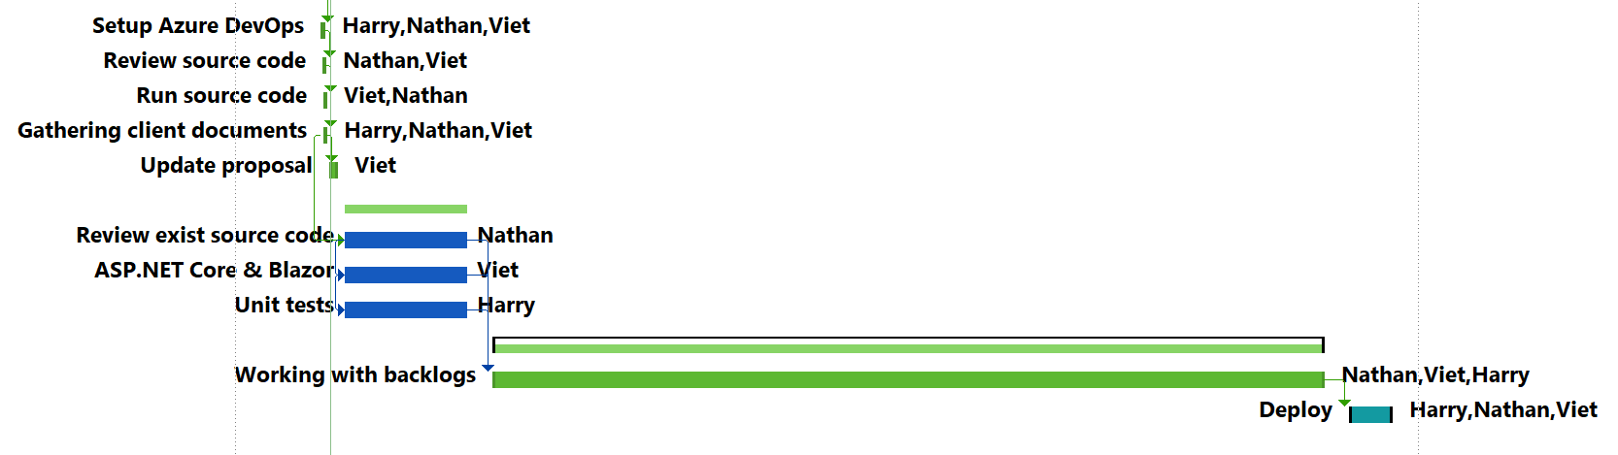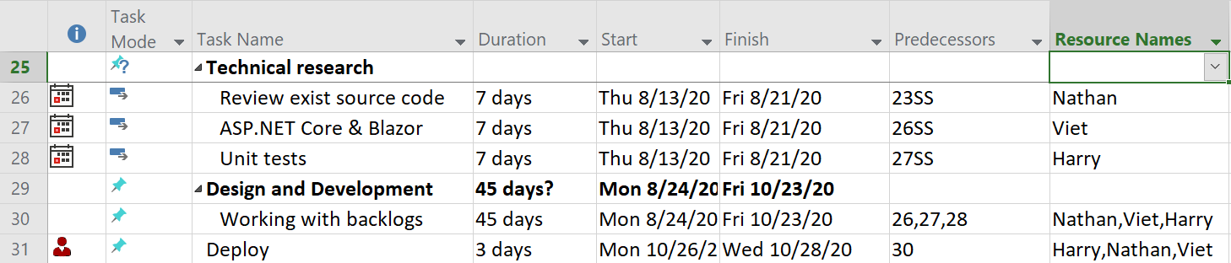

1. Proposed methodology (Phuc’s)

- Explain the step need to do

1. Expected outcomes (Harry’s)

- What we expect to achieve

Skill and knowledge involved

|  |  |  |
| --- | --- | --- |
| **Developers** | **Personal skills** | * Analytical skills * Teamwork skills * Self-learning * Workspace adaption * Communication skills * Strong written * Critical thinking * Research skills |
| **Project Management skills** | * Learning methodologies * Understand SDLC * Leadership * Team management * Negotiation skills * Well-organization skills * Risk management * Planning skills * Quality management * Problem solving |
| **Professional skills** | * Web development. * Design pattern. * C# and ASPNET Core. * SQL * HTML, CSS and Javascript * Graphic design UI/UX * Unit test. * Testing process. * Fix bug technique. |

1. Cost estimation

|  |  |  |  |  |  |  |  |
| --- | --- | --- | --- | --- | --- | --- | --- |
| No | Type | Harry | | Nathan | | Viet | |
| 1 | Public transport | 5 Zone | $5.40 |  |  |  |  |
| 2 |  |  |  |  |  |  |  |
| 3 |  |  |  |  |  |  |  |

1. Abbreviation & Names

|  |  |  |
| --- | --- | --- |
| No. | Abbreviation & Names | Meaning |
| 1 | SDLC | Software development life cycle |
| 2 | C# | Computer programming language, developed by Microsoft Corporation |
| 3 | ASP.Net Core | Web framework, developed by Microsoft Corporation |
| 4 | SQL | Structured Queuing Language |
| 5 | HTML | Hypertext Markup Language |
| 6 | CSS | Cascading Style Sheets |
| 7 | Javascript | A programming language that conforms to the ECMAScript specification |
| 8 | UI | User interface |
| 9 | UX | User experience |
| 10 | Zoodata | New name of task tracker |
| 11 | Git |  |
| 12 | Blazor WebAssembly | New Microsoft frontend frame |
| 13 | Azure DevOps |  |
| 14 | DI | Dependency injection |
| 15 | AAD | Azure active directory |

1. References